Dealer.com
Responsive Notes:
DDC suggests creating assets designed specifically for mobile that reduce text, increase font sizes, and adjust the general layout with smaller device screen spaces in mind.

Homepage Sliders

Desktop:
960x350 Safe Zone (Will never be cut off or obscured. Safe for text.)
1120x514 Bleed Area (May be cut off or obscured at certain breakpoints / certain templates.)
Default (T11) | 1400x514
Default Wide (T11) (Recommended) | 2000x514
Audi | 1800x514
BMW | 1900x776
CDJR | 1400x514
Ford (Old) | 1620x540
Ford (Recommended) | 2000x515
Jaguar | 1800x514
Land Rover | 1440x387
Lincoln | 1600x514
MINI | 1645x517
Subaru | 1800x550
Toyota (Shift uploads at this size) | 1560x570
Volkswagen | 1620x506
Volvo | 1600x600

Mobile:
1024x768 (4:3)

Tiles
“Specials Listings Widget”

Desktop:
1 Column | 936x467
2 Column (Default for vehicle specials) | 456x462
3 Column (Default for fixed ops coupons) | 296x454
4 Column | 216x442

Mobile:
1024x768 (4:3) (Also recommend this for pop-ups?)

Banners
No rigid recommendation for height. Minimize to prevent page content from being pushed down. Should be consistent if rotating with others.

Text-based banners and Managed Creative standard: 150 height.
Homepage Banners - match HS width or 2000px

If new SRP is in use - SRP banner is 1400px

Desktop:
Default | 950x
BMW | 1200x
Lexus | 1200x
Subaru | 1400x
Volkswagen | 1400x

Mobile: Same size as desktop (Per DDCMC)

Homepage Collage
These locations are intended for use with decorative/background imagery - caution should be used when adding content with text (generous safe zones).

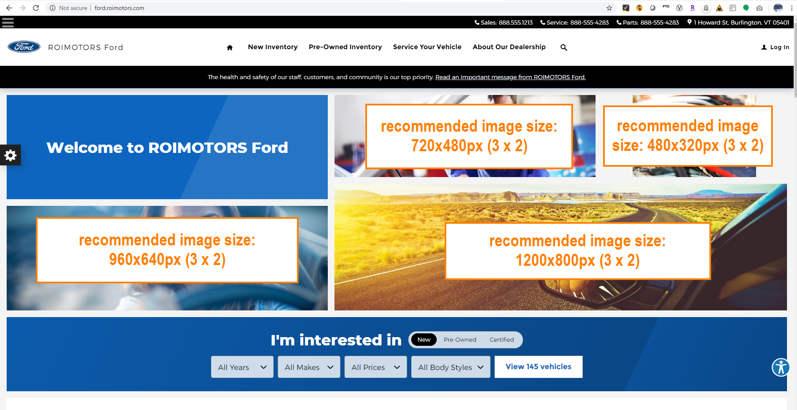
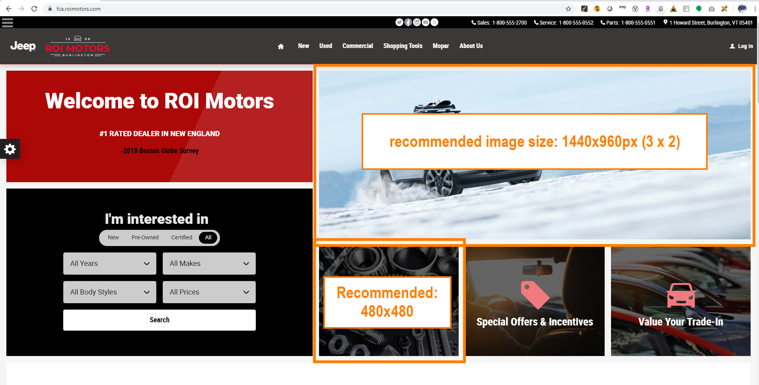

Homepage Hero Background
Desktop: 1800x600(960x350) (Position content with search widget in mind)
Mobile: 300x500 (Search widget takes up majority of space, suggest background image only)

Dealer Inspire

Homepage Sliders
Default | 1800x760
Acura | 1920x640
BMW | 1900x705
FCA | 1920x705
GM | 1760x800
Infiniti | 1600x560
Kia | 1400x514
Lexus | 1920x601
Porsche | 1600x685
Toyota | 1920x614
Volvo | 1920x824
VW | 1920x450

Mobile: 600x400 (3:2)

Tiles
“Special Offers Plugin”
600x400 (3:2)
Text based specials recommended for SEO purposes.
(Can use vehicle’s photo, or decorative header image.)

Banners
Width: 1400px

DealerOn
Responsive Notes:
DealerOn suggests generating one version of the image that will work on both desktop and mobile, to minimize extra load time.

Homepage Sliders
Full Width Carousel: 1920x600
Smaller Carousel: 880x320 (Found on some templates, misc use)

Tiles
“Enterprise Specials Manager”

Full Width | 1920x600
½ Width | 800x400
⅓ Width | 600x400

Banners
Width: 1200px

Sincro (CDK)
Responsive note: Sincro recommends building a single image suitable for both Desktop and Mobile. All sites are responsive.

Reference? http://dsonlinehelp.com/PID/oh/en_US/pid/help/applications/ab_websitemanager_cl/MM070/Content/My_Topics/Tasks/ImageBestPractices.htm?Highlight=image%20size

Homepage Sliders
Default: 1600x686

Tiles
Full Width: 1600x686 (Homepage Slider)
½ Width: 800x686

Banners
Full Width: 2000px
Gutters (¾ Width): 1660px

FusionZone

Homepage Sliders
1440x440

Tiles
440x200
(Recommendation is for decorative image for use with text based special. If full special is to be contained within the image, taller height recommended. Something like 440x660)

Banners
Width: 1440px

Dealer Fire

Homepage Sliders
Desktop:
1410px Center Safe Zone
Default | 1920x640
Toyota | 1920x614

Mobile: 768x500

Tiles
768x500

Banners
Width: 1000px

